Press Release: Trelleborg Group
Release Immediate: April 25, 2019
Trelleborg Inaugurates New Seals & Profiles Manufacturing Facility in US
On the 17 April, Trelleborg’s seals & profiles operation inaugurated a newly constructed manufacturing facility in Aurora, Ohio, to manufacture high-performance sealing profiles, such as building facade seals, automotive cable protectors and fuel tank straps, road and bridge expansion joint seals, as well as other critical sealing components.
The investment is part of Trelleborg’s continued long-term strategy to invest in markets with favorable growth potential. The site, which covers a total of 15,160 square meters/156,000 square feet, will produce extruded sealing profiles using proven leading-edge manufacturing processes. The state-of-the-art facility will serve the needs of Trelleborg’s existing and future customers within the building construction, automotive, and aerospace industries.
Magnus Andersson, Business Unit President for Trelleborg’s seals & profiles operation, says: “We believe that this new facility will further strengthen our market position, providing market leading capabilities. Consolidating our manufacturing in Aurora will optimize production flow to the benefit of our customers. We look forward to further developing our business, working closely with existing customers and new ones.”
Smith McKee, General Manager and Product Area Director for Trelleborg’s seals & profiles operation in the Americas, says: “Coming together under one roof in this new facility is a proud moment for the whole team. Our facility will continue to serve customers both near and far, truly being both local and global. The intention is to develop a world class manufacturing hub that will service and support the Americas market.”
The new Ohio facility allowed Trelleborg to consolidate operations from two manufacturing sites in Aurora as well as its Bristol, Indiana site. The site in Bristol was closed in December 2018, adding about 90 new employees in Aurora with a total U.S. headcount of 165 employees within the seals & profiles operation.
The inauguration on April 17 was attended by guests from all over the world, including representatives from customers, suppliers, along with key members of the local authorities and management and personnel from Trelleborg.
The Trelleborg Group has a number of facilities and sales offices in the U.S.. The facilities develop and manufacture a broad range of Trelleborg’s engineered products and solutions based on polymer technology. Trelleborg has about 2,910 employees in the U.S. and sales in 2018 amounted to SEK 7,136 million (approximately USD 823 million).
- END -

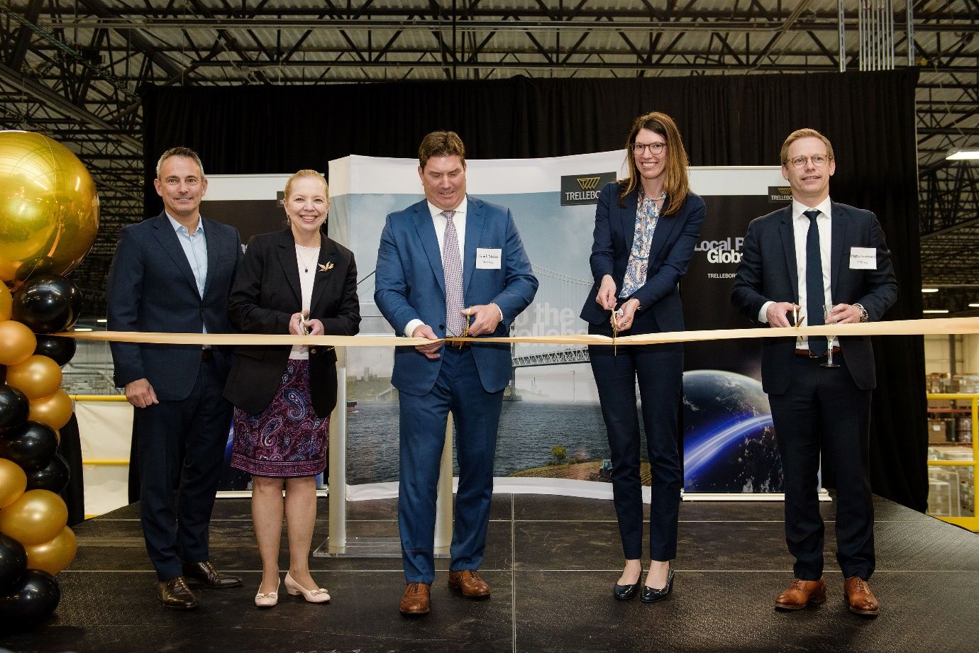

Caption: The ribbon cutting ceremony at the inauguration of Trelleborg Seals & Profiles new manufacturing facility in Aurora, Ohio, on 17 April. From left, Jean-Paul Mindermann, President at Trelleborg Industrial Solutions; Ann Benjamin, Mayor in Aurora; Smith McKee, General Manager and Product Area Director for Trelleborg’s seals & profiles operation in the Americas; Kathleen Clyde Portage County commissioner and Magnus Andersson, Business Unit President for Trelleborg’s seals & profiles operation.

For more information or high resolution images, please contact:

Smith McKee, General Manager
Telephone: +1 330 995 9725
Email: smith.mckee@trelleborg.com
www.trelleborg.com/en/sealing-profiles
Information about Trelleborg Group
Trelleborg is a world leader in engineered polymer solutions that seal, damp and protect critical applications in demanding environments. Its innovative solutions accelerate performance for customers in a sustainable way. The Trelleborg Group has annual sales of about SEK 34 billion (EUR 3.32 billion, USD 3.92 billion) and operations in about 50 countries. The Group comprises five business areas: Trelleborg Coated Systems, Trelleborg Industrial Solutions, Trelleborg Offshore & Construction, Trelleborg Sealing Solutions and Trelleborg Wheel Systems. The Trelleborg share has been listed on the Stock Exchange since 1964 and is listed on Nasdaq Stockholm, Large Cap. www.trelleborg.com

