Press Release For immediate distribution

Trelleborg enhances support for semiconductor
customers with Malta facility expansion

Trelleborg Sealing Solutions marks a key milestone in our semiconductor strategy to be a global partner for growth with the opening of an enhanced and expanded European production center in Malta.
Increased manufacturing presence and capacity in Europe enables Trelleborg to offer semiconductor manufacturers shorter lead times, enhanced business continuity, more flexibility and increased speed to market for sealing and damping solutions.
Chris Busby, Global Segment Director Semiconductor, says: “This investment enhances our ability to offer chip manufacturers global R&D and expertise combined with the advantages of in-region manufacturing, reducing the risk faced by customers in the current climate of geopolitical uncertainty.
“The site has added over 500 square meters/5,382 square feet of cleanroom space and will focus on fluoroelastomer (FKM) and perfluoroelastomer (FFKM) products with options to extend capabilities in the future. The investment reinforces Trelleborg’s commitment to support the ambitions of the European Chips Act.”
The expanded facility in Hal Far and Marsa is Trelleborg’s third semiconductor-focused manufacturing space alongside facilities in Tewkesbury in the UK and Yongin in South Korea. It also houses new advanced production facilities for the fast-evolving life sciences and biopharmaceutical sector, a major investment furthering Trelleborg’s commitment to innovation and excellence in the Maltese economy.
Established in Malta since 1961, Trelleborg continues to anchor itself as a pillar in the island’s manufacturing, developing skills and creating new jobs, with its workforce expected to increase to 600 employees to meet the new business demands.
Trelleborg is also launching a new range of innovative fluorosurfactant-free materials*. As global regulators and semiconductor manufacturers increasingly focus on reducing per- and polyfluoroalkyl substances (PFAS) due to their potential impacts on human health and the environment, Trelleborg has added three new fluorosurfactant-free materials to its extensive PureFab® materials range.
Busby adds: “These two new high-temperature perfluoroelastomers (FFKM) and one fluoroelastomer (FKM) materials are ‘fluorosurfactactant free’, meaning they are made without low-molecular-weight PFAS fluorosurfactants. As regulations to reduce PFAS use evolve, these new materials help future proof customers against regulatory risk and strengthen their supply chain.”
The new materials expand the extensive Trelleborg range of semiconductor solutions designed to perform and prevent premature failure in the extreme temperatures and more aggressive chemical precursors increasingly characterizing semiconductor environments. The entire Isolast® PureFab® range includes materials providing excellent performance in aggressive front-end processes including deposition, etch, ash/strip, plasma cleaning and thermal processing such as atomic layer deposition.
Trelleborg Sealing Solutions is a key supplier of polymer technologies that meet the ever-increasing challenges of the semiconductor industry, offering decades of engineering and applications experience, as well as the latest knowledge in the design of high-precision, customized sealing solutions for critical semiconductor applications.
As AI, 5G, machine learning, high-performance computing and miniaturization drive higher performance demands, Trelleborg's high-performance seals deliver the cleanliness, chemical resistance and extended uptime customers need to maximize yield.
For more on the extensive Trelleborg range of sealing solutions for semiconductor manufacturing: https://www.trelleborg.com/en/seals/your-industry/semiconductor
-ends-
* PFAS-surfactant-free materials mean that PFAS-surfactants are not used intentionally. To the best of our knowledge and based on available information, these materials do not contain PFAS-surfactants. However, it cannot be guaranteed that these may contain trace amounts of PFAS-surfactants that occur unintentionally.

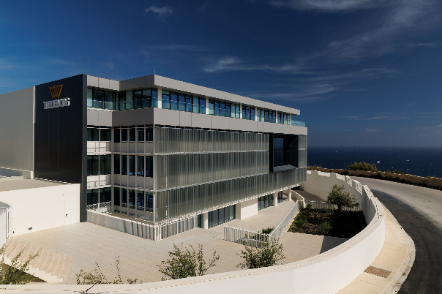
Caption: Trelleborg Sealing Solutions marks a key milestone in our semiconductor strategy to be a global partner for growth with the opening of an enhanced and expanded European production center in Malta.

For more information, please contact:
Paul Ravenscroft
Tel: +44 (0) 7890 419312
Email: paul.ravenscroft@trelleborg.com

About Trelleborg Sealing Solutions and Trelleborg Group
Trelleborg Sealing Solutions combines deep materials and applications expertise with close customer collaboration to fulfil our mission as a leading provider of precision seals, bearings and custom polymer components. We focus on meeting the most demanding needs of aerospace, food and beverage, semiconductor and general industrial customers. With a strong emphasis on local engineering, manufacturing and supply capabilities, we support our customers working side by side to deliver tailored solutions for their specific needs. Our global network of over 35 production facilities, more than 60 Customer Solution Centers and 15 R&D centers ensures responsive support and seamless cooperation at a local level. Through innovative products, proprietary materials and a commitment to excellent service, we empower customers to achieve their goals, locally and globally.www.trelleborg.com/seals

Trelleborg leverages in-depth materials and applications expertise with early market insights, making the Group a world leader in engineered polymer solutions. We offer a unique portfolio covering a broad range of applications – even the most complex ones. In 2025, Trelleborg Group reported annual sales of approximately SEK 34 billion, with operations in around 40 countries. The Group comprises three business areas: Trelleborg Industrial Solutions, Trelleborg Medical Solutions, and Trelleborg Sealing Solutions. The Trelleborg share has been listed on the Stock Exchange since 1964 and is traded on Nasdaq Stockholm, Large Cap. www.trelleborg.com

