Press release For immediate distribution

Trelleborg launches Turcon® SG to optimize

CTIS performance in off-highway vehicles
Trelleborg Sealing Solutions launches Turcon® SG, a range of specialized sealing components engineered to optimize performance of central tire inflation systems (CTIS) in challenging off-highway environments.
Built for agriculture, mining, construction and forestry vehicles, the Turcon® SG rotary seal delivers reliable, low-friction sealing that maintains system airtightness throughout every inflation and deflation cycle, enabling seamless transitions between road and field.
Tobias Corneli, Expert Network Manager EMEA, says: "Delivering measurable performance and efficiency gains, the innovative Turcon® SG optimizes CTIS functionality for a wide array of off-highway vehicles operating across varying surface conditions from smooth tarmac to agroforestry conditions.
"By automatically adjusting tire pressure to suit varying ground conditions, CTIS systems sealed with Turcon® SG support up to 15% reduced fuel consumption and lower CO₂ emissions, improving traction and safety and reducing soil compaction. Combined with its extended service life, the seal significantly cuts downtime and total cost of ownership for custimers."
The Turcon® SG seal tackles one of the most demanding challenges in CTIS engineering: maintaining reliable sealing under continuous rotary motion and typical pneumatic pressure while minimizing friction and wear across thousands of operating hours traversing varying ground conditions.
Its pressure-activated design holds the polytetrafluoroethylene (PTFE) sealing lip in an unpressurized, near-zero-friction state for 90 to 95 percent of its operating cycle. When pressure is applied, the lip activates immediately against the countersurface to deliver a reliable, airtight seal. This approach directly extends service life beyond 10,000 hours, cutting customers’ maintenance requirements and increasing vehicle uptime.
Turcon® SG integrates a built-in static elastomer seal and a guiding element, delivering consistent performance and compensating for hardware tolerances across a wide range of axle configurations. Its all-in-one modular design consolidates multiple functions, including scrapers and radial shaft seals, into a single compact assembly, simplifying installation and supporting high-volume automated production.
Trelleborg offers the Turcon® SG Seal as both an integrated axle solution and an external solution, accommodating trailer- and driven-axle configurations across single- and dual-channel variants. It is an ideal solution to optimize CTIS functionality on vehicles including tractors, sprayers, combines, harvesters, forwarders, trucks, dump trucks and wheel loaders.
-ends-
Press image
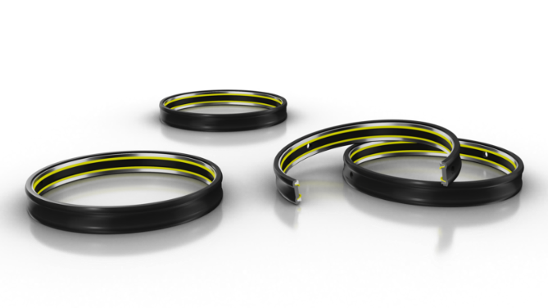
Caption: The Turcon® SG range of specialized sealing components is engineered to optimize performance of central tire inflation systems (CTIS) in challenging off-highway environments.

For more information, please contact:
Paul Ravenscroft
Tel: +44 (0) 7890 419312
Email: paul.ravenscroft@trelleborg.com

About Trelleborg Sealing Solutions and Trelleborg Group
Trelleborg Sealing Solutions combines deep materials and applications expertise with close customer collaboration to fulfil our mission as a leading provider of precision seals, bearings and custom polymer components. We focus on meeting the most demanding needs of aerospace, food and beverage, semiconductor and general industrial customers. With a strong emphasis on local engineering, manufacturing and supply capabilities, we support our customers working side by side to deliver tailored, solutions for their specific needs. Our global network of over 35 production facilities, more than 60 Customer Solution Centers and 15 R&D centers ensures responsive support and seamless cooperation at a local level. Through innovative products, proprietary materials and a commitment to excellent service, we empower customers to achieve their goals, locally and globally. www.trelleborg.com/seals
Trelleborg leverages in-depth materials and applications expertise with early market insights, making the Group a world leader in engineered polymer solutions. We offer a unique portfolio covering a broad range of applications – even the most complex ones. In 2025, Trelleborg Group reported annual sales of approximately SEK 34 billion, with operations in around 40 countries. The Group comprises three business areas: Trelleborg Industrial Solutions, Trelleborg Medical Solutions, and Trelleborg Sealing Solutions. The Trelleborg share has been listed on the Stock Exchange since 1964 and is traded on Nasdaq Stockholm, Large Cap. www.trelleborg.com

