Press release For immediate distribution
Hydrogen Technology Expo 2026
Hamburg Messe, Germany
October 20 to 22
Booth 6P40-2, Hall 6

Trelleborg Showcases Proven Solutions
at Hydrogen Tech Expo 2026

Trelleborg Sealing Solutions showcases solutions and capabilities for the entire hydrogen value chain at Hydrogen Technology Expo 2026, from October 20 to 22 at Hamburg Messe, booth 6P40-2 in Hall 6.
Trelleborg highlights its expanding H₂Pro™ range of 20-plus materials proven for applications in the production, transport and storage, and end-use of hydrogen, including its FlexiBond solution, designed for use in electrolyzers and fuel cells.
James Simpson, Global Segment Director Energy, says: “Our comprehensive range of more than 20 H₂Pro™ materials, proven in our proprietary testing regimes to meet the requirements of real-world hydrogen applications, are now available for customers across the hydrogen value chain.
“We will showcase one of our latest innovations in the H₂Pro™ portfolio, FlexiBond. It enables new design possibilities for electrolyzers and fuel cells by combining the capabilities of large frame seals with a high-stability shape, and reduces the level of investment needed for complex injection molding equipment.”
H₂Pro™ materials provide optimal sealing solutions in challenging hydrogen environments including high pressures and low temperatures, and are characterized by minimal hydrogen permeation, resistance to rapid gas decompression (RGD) and excellent abrasion and extrusion properties. The materials can be used to create engineered molded parts including frame seals, rubber-to-metal and rubber-to-plastic components, and multicomponent solutions for valves, electrolyzers and fuel cell stacks.
Also featured at the show is the Turcon® Variseal® range for optimal solutions in the cryogenic temperatures of liquid hydrogen. Designed for optimal sealing in extreme pressure and temperature conditions, they are made from high-performance polymers and are available in various geometries that can be customized for specific applications, with options for both static and dynamic sealing.
Trelleborg also demonstrates solutions that support the creation of “green hydrogen”, produced when renewable energy is used to power water electrolysis. Seals in electrolysis equipment play a critical role in ensuring efficiency, maintaining the separation of the hydrogen and oxygen produced, and protecting hardware from electrochemical attacks. Trelleborg has a range of optimal solutions, including HMF FlatSeal™ flat gaskets and frame gaskets, and rubber-to-metal bonded gaskets, that excel in the extreme temperatures of +50 °C to +160 °C/+122 °F to +320 °F, pressures up to 80 bar/1,160psi and the electrochemical attack in all electrolyzer technologies
Trelleborg also showcases industry-leading R&D capabilities for the hydrogen sector, including its 93 sq meter/1,000 sq feet dedicated hydrogen test facility in Fort Wayne, Indiana, US, established to help customers navigate the challenges of the entire hydrogen value chain.
The facility’s testing capabilities include hydrogen leak detection, rapid gas decompression, compatibility, dynamic testing and permeation testing. Tests at pressures up to 1,034 bar/15,000 psi and across all temperature ranges from cryogenic to above 180 °C/350 °F are available, and pressure cycle testing at various environmental temperature profiles.
-ends-

.

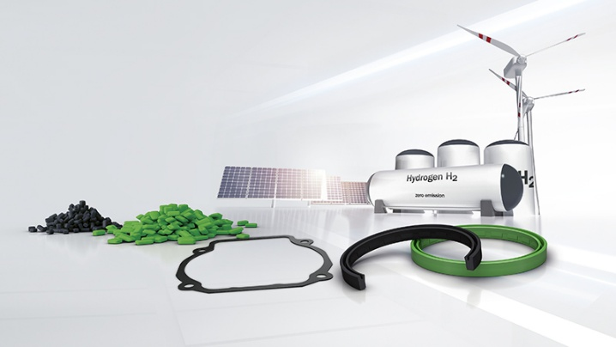
Caption: The comprehensive Trelleborg range of more than 20 H₂Pro™ materials, proven in our proprietary testing regimes to meet the requirements of real-world hydrogen applications, support customers across the hydrogen value chain with reliable solutions.
Credit: Trelleborg Sealing Solutions

For more information, please contact:
Paul Ravenscroft
Tel: +44 (0) 7890 419312
Email: paul.ravenscroft@trelleborg.com
About Trelleborg Sealing Solutions and Trelleborg Group

Trelleborg Sealing Solutions combines deep materials and applications expertise with close customer collaboration to fulfil our mission as a leading provider of precision seals, bearings and custom polymer components. We focus on meeting the most demanding needs of aerospace, food and beverage, semiconductor and general industrial customers. With a strong emphasis on local engineering, manufacturing and supply capabilities, we support our customers working side by side to deliver tailored, solutions for their specific needs. Our global network of over 35 production facilities, more than 60 Customer Solution Centers and 15 R&D centers ensures responsive support and seamless cooperation at a local level. Through innovative products, proprietary materials and a commitment to excellent service, we empower customers to achieve their goals, locally and globally.www.trelleborg.com/seals
Trelleborg leverages in-depth materials and applications expertise with early market insights, making the Group a world leader in engineered polymer solutions. We offer a unique portfolio covering a broad range of applications – even the most complex ones. In 2025, Trelleborg Group reported annual sales of approximately SEK 34 billion, with operations in around 40 countries. The Group comprises three business areas: Trelleborg Industrial Solutions, Trelleborg Medical Solutions, and Trelleborg Sealing Solutions. The Trelleborg share has been listed on the Stock Exchange since 1964 and is traded on Nasdaq Stockholm, Large Cap. www.trelleborg.com

