Press release For immediate distribution

Rotary Sealing in Motion: Join the Trelleborg ConneX
event to discover next-generation sealing solutions

Trelleborg Sealing Solutions hosts "Rotary Sealing in Motion," a 2.5-hour free virtual ConneX event exploring the technologies, trends and engineering expertise shaping the future of rotary sealing. Broadcasting from the Trelleborg Innovation Center in Stuttgart, Germany, the event is designed for engineers and technical decision-makers seeking practical guidance on seal selection, application performance and emerging industry challenges.

Two identical sessions on September 22, 2026 make the livestream accessible for a global audience, with one starting at 15.00 CST/09.00 CEST for customers in APAC & Europe and 10.00 EDT/16.00 CEST for customers in the Americas and Europe.

Dr. Konrad Saur, Vice President Innovation and Strategic Business Development, says: "Rotary sealing requirements are evolving rapidly as industries pursue higher efficiency, greater reliability and increasingly electrified and automated systems. Selecting the right sealing solution has become a critical engineering decision that directly affects performance, uptime and sustainability. With ’Rotary Sealing in Motion,’ we want to share practical expertise, emerging technology trends and the latest innovations helping engineers address these challenges with confidence."

The program of six sessions spans the full breadth of rotary sealing. Topics include seal types and selection criteria, real-world application insights from trucks and off-highway environments and a forward-looking technology view on what the next generation of rotary seals will deliver. The final session covers sealing requirements for next-generation robotics, and features a speaker from ABB, specialists in electric motors, drives, generators and motion control with digital powertrain solutions.

Pascal Freund, Global Segment Director Manufacturing and Automation adds: "Engineers today must balance a complex combination of operating parameters, from speed and pressure to temperature, media compatibility and space constraints. Small specification errors can have significant consequences in terms of system reliability and operating costs. This event has been designed to provide practical guidance, real application insights and direct access to sealing experts, helping attendees to make optimal decisions throughout the design process."

Alongside the technical program, the event will also highlight three recent additions to Trelleborg's Stefa® rotary sealing portfolio.

Among the featured developments is the Stefa® High-Performance Radial Shaft Seal range, engineered to reduce frictional torque, improve energy efficiency and extend service life in demanding industrial applications. The portfolio addresses the growing need for lower energy consumption and increased uptime in modern manufacturing environments.

Attendees will also gain insight into the Stefa® High-Pressure Radial Shaft Seal portfolio, developed to deliver reliable sealing performance in applications exposed to demanding pressures, challenging operating conditions and high-value equipment where durability and operational reliability are critical.

In addition, the event will highlight the Stefa® Mini Radial Shaft Seal range, specifically developed for next-generation robotics and automation systems. Designed for compact installation spaces, high accelerations and fast-moving rotary applications, the solutions support the growing demand for lighter, smaller and more efficient robotic systems.

The event is free and will be held in English. Registration and more information can be found at: https://www.trelleborg.com/en/seals/news-and-events/news/rotary-sealing-in-motion-virtual-event
-ends-

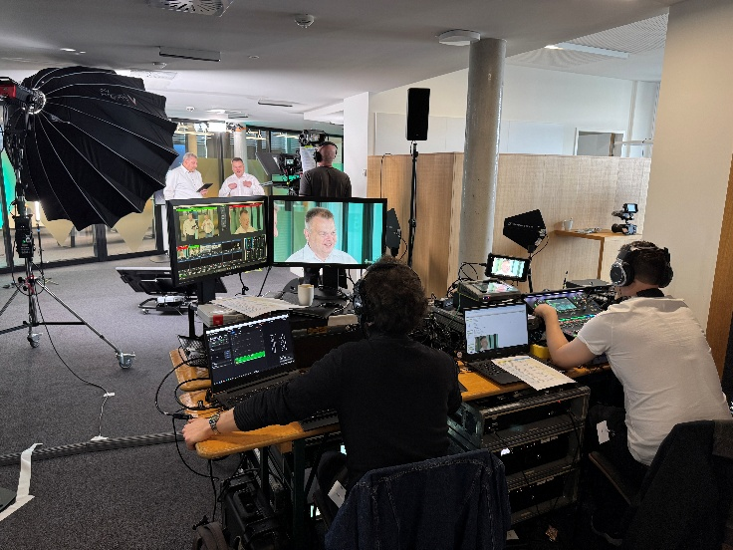

Caption: Livestreamed from the Trelleborg Sealing Solutions Innovation Center in Stuttgart, Germany, the ConneX event “Rotary Sealing in Motion” by Trelleborg Sealing Solutions will take place online on September 22, 2026. Credit: Trelleborg Sealing Solutions.



Caption: Trelleborg Sealing Solutions' Rotary Sealing in Motion virtual event explores the latest advances in rotary sealing technologies, product innovations and engineering trends shaping the future of industrial, automation and mobility applications. Credit: Trelleborg Sealing Solutions.

For more information, please contact:
Paul Ravenscroft
Tel: +44 (0) 7890 419312
Email: paul.ravenscroft@trelleborg.com

About Trelleborg Sealing Solutions and Trelleborg Group

Trelleborg Sealing Solutions combines deep materials and applications expertise with close customer collaboration to fulfil our mission as a leading provider of precision seals, bearings and custom polymer components. We focus on meeting the most demanding needs of aerospace, food and beverage, semiconductor and general industrial customers. With a strong emphasis on local engineering, manufacturing and supply capabilities, we support our customers working side by side to deliver tailored solutions for their specific needs. Our global network of over 35 production facilities, more than 60 Customer Solution Centers and 15 R&D centers ensures responsive support and seamless cooperation at a local level. Through innovative products, proprietary materials and a commitment to excellent service, we empower customers to achieve their goals, locally and globally.www.trelleborg.com/seals

Trelleborg leverages in-depth materials and applications expertise with early market insights, making the Group a world leader in engineered polymer solutions. We offer a unique portfolio covering a broad range of applications – even the most complex ones. In 2025, Trelleborg Group reported annual sales of approximately SEK 34 billion, with operations in around 40 countries. The Group comprises three business areas: Trelleborg Industrial Solutions, Trelleborg Medical Solutions, and Trelleborg Sealing Solutions. The Trelleborg share has been listed on the Stock Exchange since 1964 and is traded on Nasdaq Stockholm, Large Cap. www.trelleborg.com

