Press release For immediate distribution
A Step Change in Automotive Sealing Solutions – the Rubore® Washer
Trelleborg Sealing Solutions launches the Rubore® Washer, a unique solution offering virtually leak-free sealing beneath screwheads to safeguard critical systems in electric vehicles.
In today’s rapidly evolving automotive industry, characterized by vehicles increasingly packed with electrical sensors and controllers, the proprietary composite technology of the Rubore® Washer provides the ultimate protection against corrosion and leakage.
Ideal wherever screws and bolts are used, the Rubore® Washer is constructed using advanced processing technologies. Rubber is vulcanized to both sides of the carrier metal to produce a practically indestructible three-layer laminate from which washers of various diameters and thickness are stamped.
Axel Weimann, Director Global Segment Automotive at Trelleborg Sealing Solutions, says: “The sensitive electronics of today’s cars must be optimally protected from external influences such as temperature, dirt, rain, snow or road salt.
"The plain washer is installed around half a billion times a day in new vehicles worldwide. But the Rubore® Washer is unique, adapting flexibly to surfaces thanks to its rubber layers. Even if the metal countersurface has tiny scratches or cavities, the external rubber layer overcomes and seals these surface imperfections.”
It is suitable wherever electrical sensors, control units or battery systems are enclosed in bolted housings, which have a clear advantage over bonded or welded alternatives due to recycling requirements and repairs. The insulating rubber layers of Rubore® Washer prevent various types of corrosion induced by metal-to-metal contact.

The Rubore® Washer is proven to perform in the harshest environments, resisting corrosion to meet the toughest original equipment manufacturer (OEM) requirements.
It is particularly effective at protecting the battery pack of electric cars, which require numerous screws or bolts. The screw seals must operate reliably in tough conditions including extreme temperatures, precipitation and road salt exposure. The Rubore® Washer seals by fully covering the screwhead and eliminating direct contact to the housing surface. This effectively prevents moisture, contaminants and corrosive agents from entering the battery housing, maintaining performance while eliminating safety hazards and minimizing corrosion.
Find out more: https://www.trelleborg.com/en/seals/products-and-solutions/latest-innovations/rubore-washer
-ends-

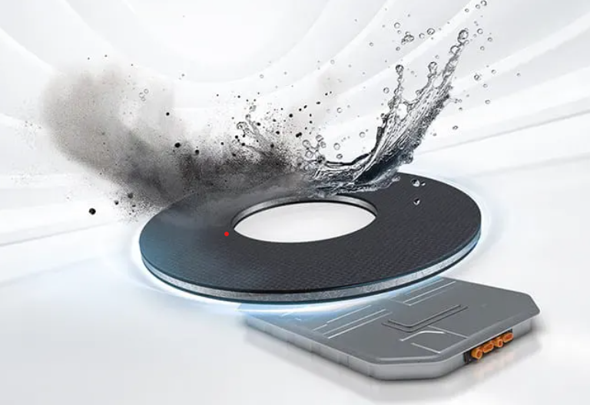

Caption: The Rubore® Washer, a solution offering virtually leak-free sealing protection along screws to safeguard critical systems for electric vehicles.

For more information, please contact:
Paul Ravenscroft
Tel: +44 (0) 7890 419312
Email: paul.ravenscroft@trelleborg.com

About Trelleborg Sealing Solutions and Trelleborg Group
Trelleborg Sealing Solutions is one of the world’s leading developers, manufacturers and suppliers of precision seals, bearings and custom-molded polymer components. It focuses on meeting the most demanding needs of aerospace, automotive and general industrial customers. The company’s global network encompasses over 40 production facilities, more than 60 Customer Solution Centers, more than 15 R&D centers and a Customer Innovation Center. It accelerates the progress of its customers through outstanding local support, an unrivaled product range including patented products and proprietary materials, a portfolio of established brands, unique process offerings, its ServicePLUS value chain solution and ‘Ease of Doing Business’ philosophy.www.trelleborg.com/seals

About Trelleborg Group
Trelleborg is a world leader in engineered polymer solutions that seal, damp and protect critical applications in demanding environments. Its innovative solutions accelerate performance for customers in a sustainable way. In 2022, the Trelleborg Group had annual sales of about SEK 30 billion in around 40 countries. The Group comprises two business areas: Trelleborg Industrial Solutions and Trelleborg Sealing Solutions. The Trelleborg share has been listed on the Stock Exchange since 1964 and is listed on Nasdaq Stockholm, Large Cap. www.trelleborg.com.

