For immediate distribution Press release

A look behind the scenes at Trelleborg - silicone
technology for precision applications

Trelleborg Sealing Solutions showcases the latest advances in silicone technology for precision applications in a free interactive webinar on March 21, 2024.
The event includes a “behind the scenes” tour of the Trelleborg Stein am Rhein production facility in Switzerland, providing an insight into its high-precision production processes - including under cleanroom conditions – and an interactive platform for experts and industry peers to share ideas.
"We will be demonstrating our entire LSR production capabilities in Stein am Rhein, from toolmaking and design through to production and quality testing," says Jarno Burkhardt, General Manager at Trelleborg Sealing Solutions, based in Switzerland. "Attendees will get a look behind the scenes of our clean rooms, where we manufacture very sophisticated parts for the healthcare & medical industry."
The session, entitled "Collaborative Innovation - Solutions in Silicone", offers insights into how Trelleborg works with customers to optimize high-quality components for industries including automotive, food and beverage, and healthcare and medical.
Trelleborg will demonstrate the development of high-precision LSR molded and multi-component parts using precision processing tools to produce high-consistency silicone rubber solutions, including components with complex geometries. These are manufactured at strategically positioned global production sites, all run in a consistent manner worldwide using the same processes and materials.
"A major advantage of our production facility in Stein am Rhein is that we have toolmaking and design here on site, primarily for new tools and customizations," says Jérôme Berger, Project Engineer at Trelleborg Sealing Solutions Switzerland AG. "We also carry out group support internally. This means that we use our experience in toolmaking and processing LSR to design and produce certain parts ourselves."
The Connex Livestream event will be held in English on March 21, 2024, from 09:45 CET to approximately 12.00 CET. Participation is free. It is broadcast live from the Trelleborg Sealing Solutions Innovation Center in Stuttgart, Germany, and is aimed at industry partners, customers and interested parties in Europe and Asia.
Highlights of the agenda include the selection and creation of LSR and high-consistency rubber (HCR) materials for specific application requirements; a virtual tour of the LSR production halls in Stein am Rhein; and a session on engineering solutions from initial concept through to series production. The event concludes with a panel discussion highlighting the technical excellence provided by customized silicone solutions.
Further information and registration details at:
https://www.trelleborg-connex.com/solutions-in-silicone/
-ends-

For more information, please contact:
Paul Ravenscroft
Tel: +44 (0) 7890 419312
Email: paul.ravenscroft@trelleborg.com

About Trelleborg Sealing Solutions and Trelleborg Group

Trelleborg Sealing Solutions is one of the world’s leading developers, manufacturers and suppliers of precision seals, bearings and custom-molded polymer components. It focuses on meeting the most demanding needs of aerospace, automotive, healthcare & medical and general industrial customers. The company’s global network encompasses over 40 production facilities, more than 60 Customer Solution Centers, more than 15 R&D centers and a Customer Innovation Center. It accelerates the progress of its customers through outstanding local support, an unrivalled product range including patented products and proprietary materials, a portfolio of established brands, unique process offerings, its ServicePLUS value chain solution and ‘Ease of Doing Business’ philosophy.www.trelleborg.com/seals

Trelleborg is a world leader in engineered polymer solutions that protect essential applications in demanding environments. Its innovative solutions accelerate performance for customers in a sustainable way. In 2023, the Trelleborg Group had annual sales of approximately SEK 34 billion in around 40 countries. The Group comprises two business areas: Trelleborg Industrial Solutions and Trelleborg Sealing Solutions. The Trelleborg share has been listed on the Stock Exchange since 1964 and is listed on Nasdaq Stockholm, Large Cap. www.trelleborg.com

Press photo:
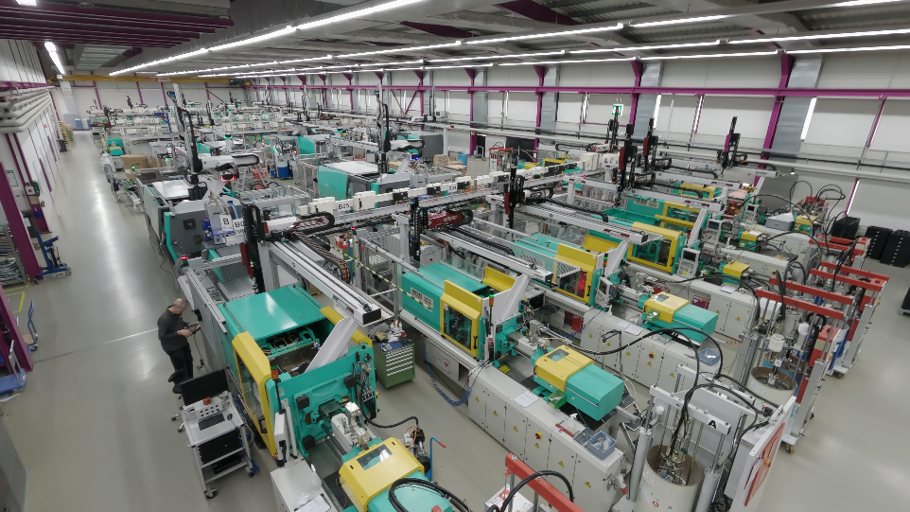

Caption: On March 21, 2024, Trelleborg Sealing Solutions will open the doors to its LSR manufacturing center in Stein am Rhein (Switzerland) in a livestream event. Photo: Trelleborg Sealing Solutions

Press contacts

Natalie Hesping
Marketing Communications & PR Manager
Trelleborg Sealing Solutions Germany GmbH
Schockenriedstr. 1
70565 Stuttgart-Vaihingen
Phone: +49 711 78 64 780
Mobile: +49 171 1105 225
E-Mail: Natalie.Hesping@trelleborg.com

Lara Hecht
European Communications & PR Manager
Trelleborg Sealing Solutions Germany GmbH
Schockenriedstr. 1
70565 Stuttgart-Vaihingen
Phone: +49 711 78 64 453
Mobile: +49 165237916
E-Mail: Lara.Hecht@trelleborg.com

About Trelleborg Sealing Solutions
Trelleborg Sealing Solutions is a leading developer, manufacturer and supplier of polymer-based precision seals, bearings and customized polymer components. With innovative solutions, it meets the most demanding requirements in the aerospace, automotive, medical and general industries. The global network includes over 40 production facilities, more than 60 Customer Solution Centers, 15 strategically positioned Research and Development Centers and a Customer Innovation Center. The company accelerates its customers' progress through outstanding local support, an unrivaled product range with patented products and proprietary materials, a portfolio of established brands, state-of-the-art manufacturing technologies, its comprehensive service offering and the "Ease of Doing Business" philosophy. www.trelleborg.com/seals

About the Trelleborg Group
Trelleborg is a world leader in the development of polymer solutions that protect essential applications in demanding environments. Our innovative solutions contribute to accelerated and sustainable development for our customers. The Trelleborg Group is present in approximately 40 countries and had annual sales of around SEK 34 billion in 2023. It comprises two business areas: Trelleborg Industrial Solutions and Trelleborg Sealing Solutions. The Trelleborg share has been traded on the Stockholm Stock Exchange since 1964 and is listed on Nasdaq Stockholm, Large Cap. www.trelleborg.com

